**Linux Command**

1. **Hostname**

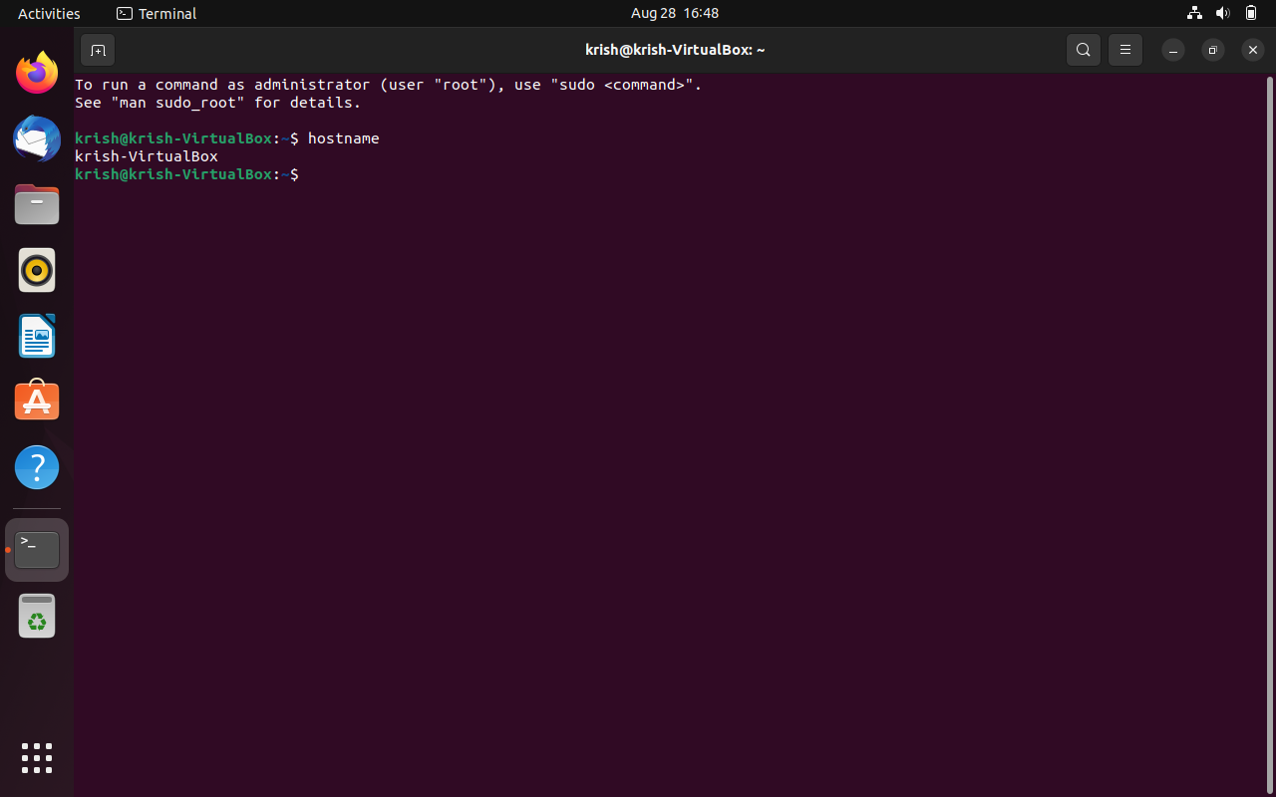

1. **Create Directory - mkdir**

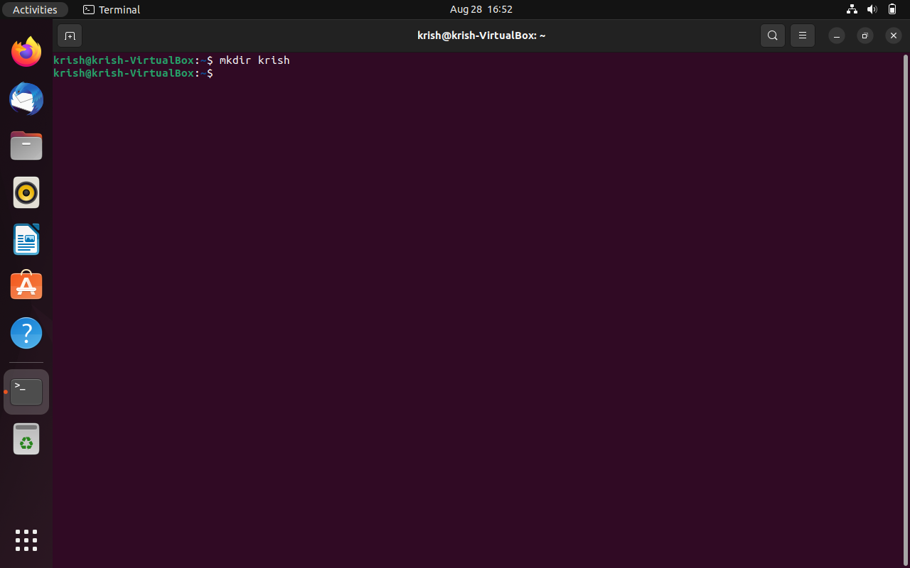

**3)** **Listing files - ls**

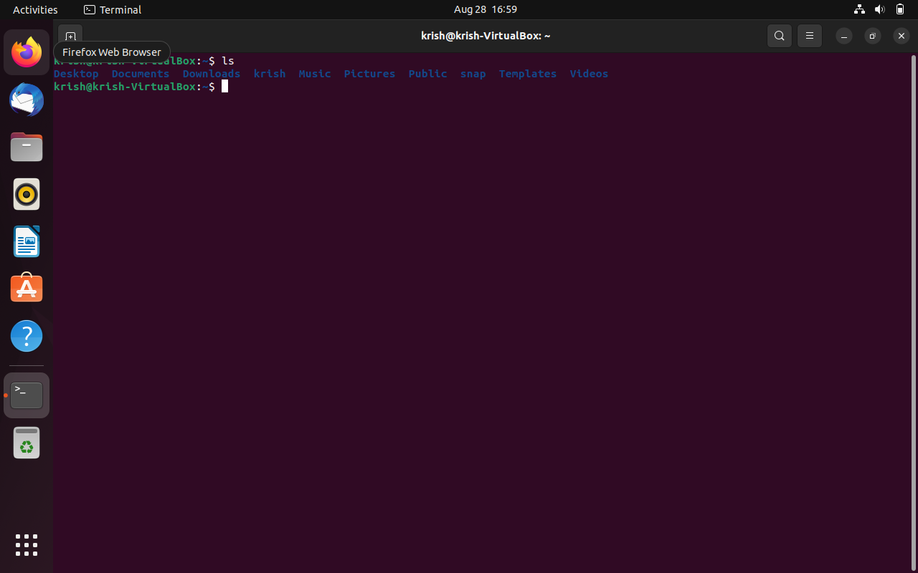

**4) Date and Time**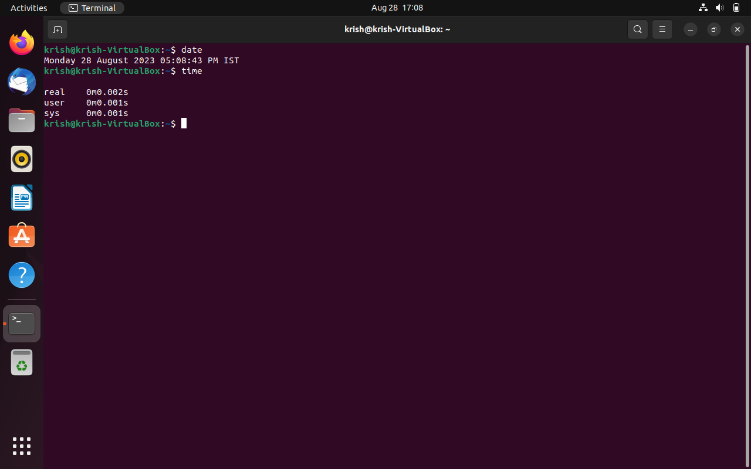

**5) Create File cat > filename.txt**

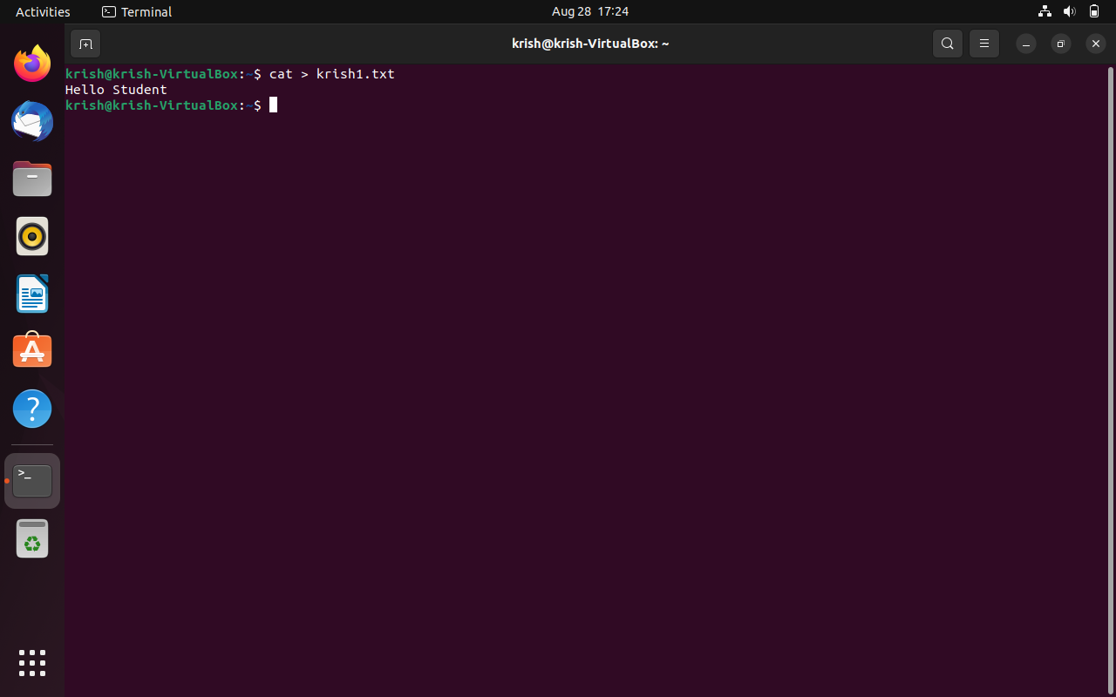

**6) Clear**

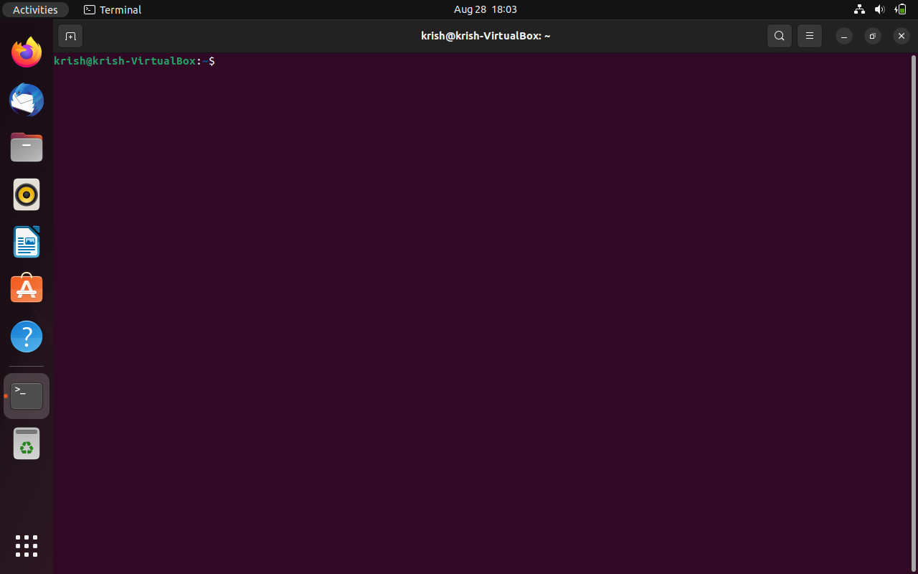

**7)** **View text files - less filename.txt**

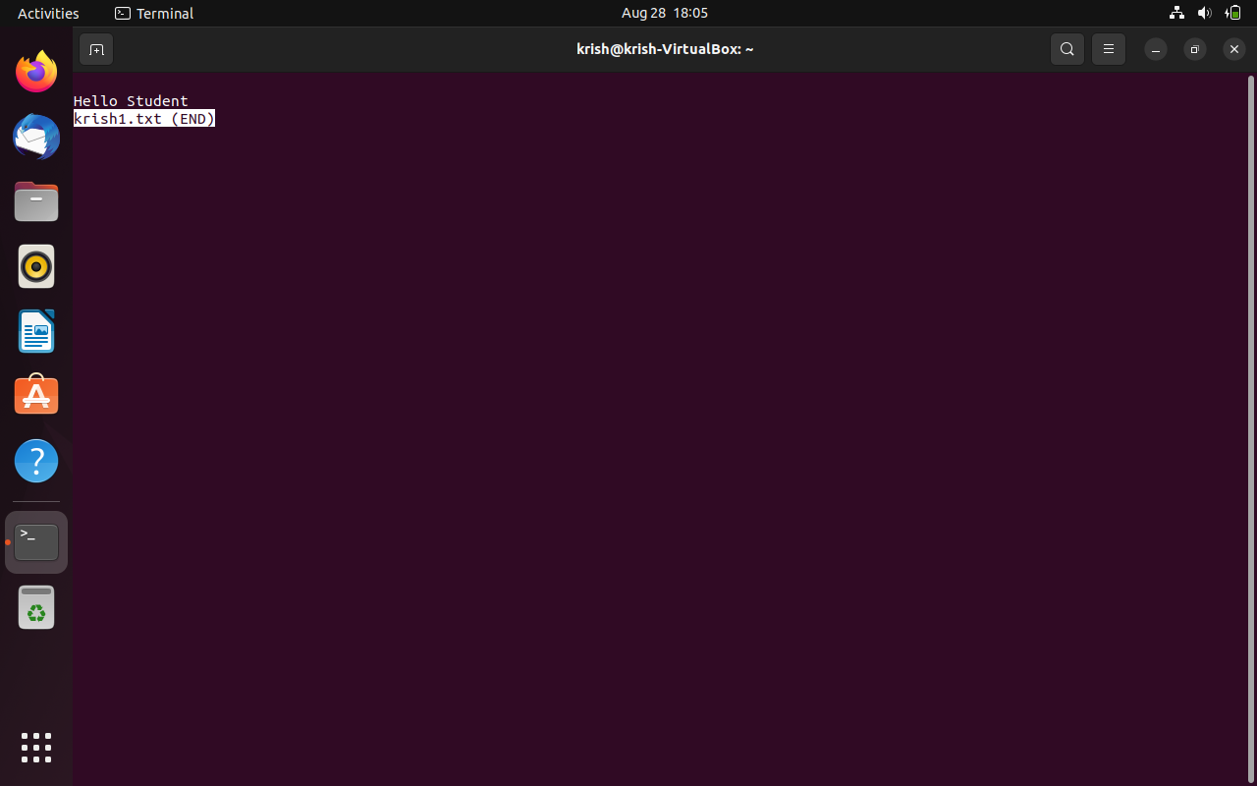

**8) Rename Files - mv <oldFilename> <newFilename>**

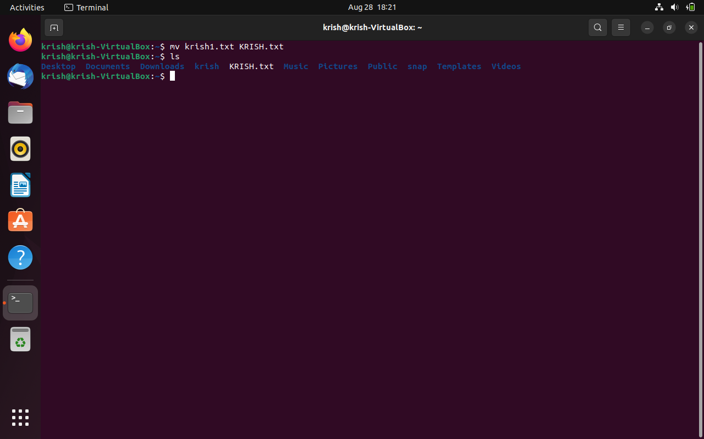

**9)** **Copy Files - cp <filename> <newLocation>**

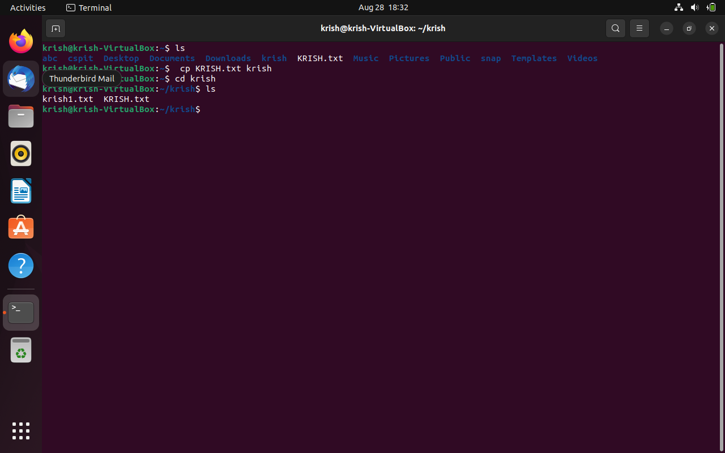

**10)** **Move Files - mv <filename> <newLocation>**

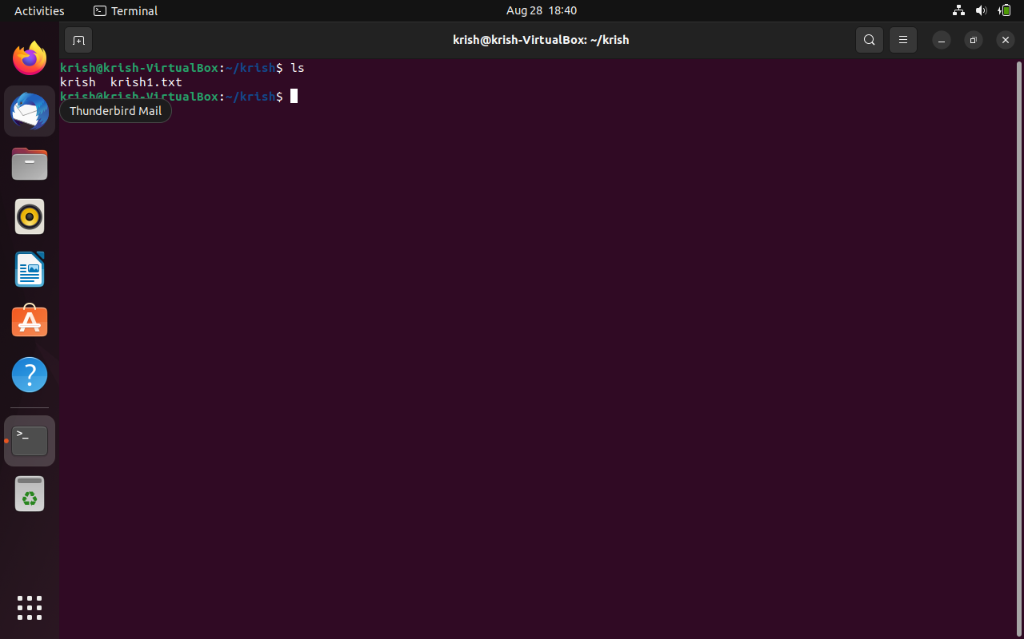

**11)** **Find files - find -name <filename>**

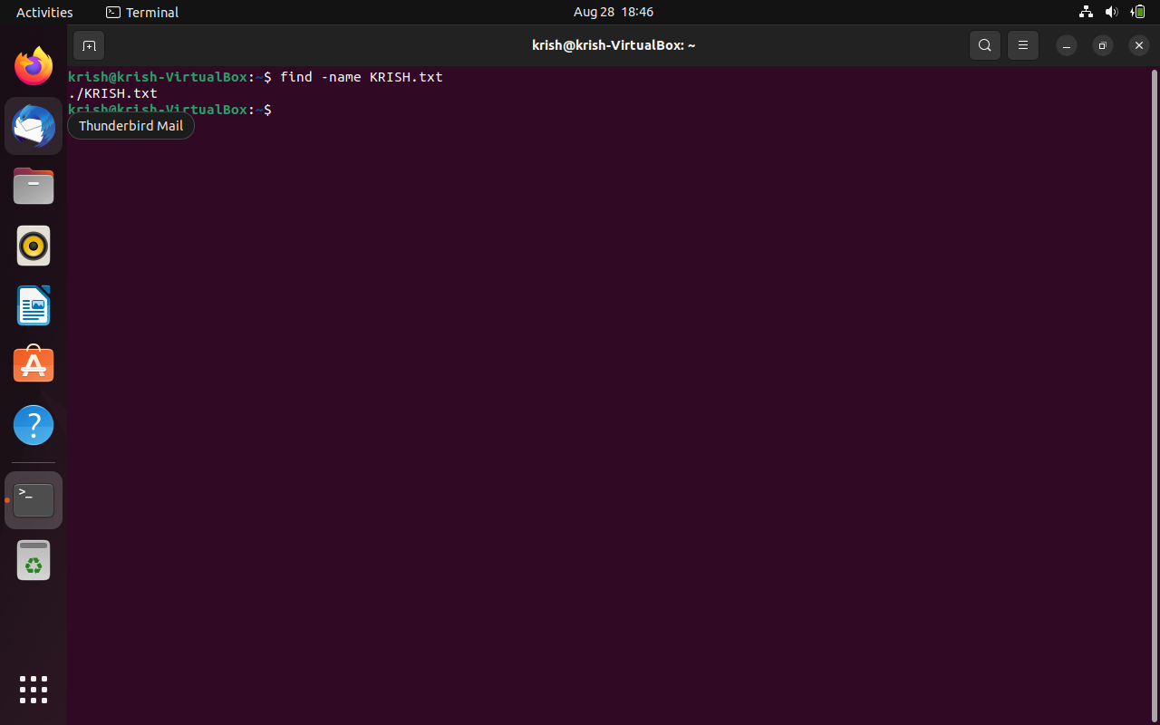

**12) Listing files - ls**

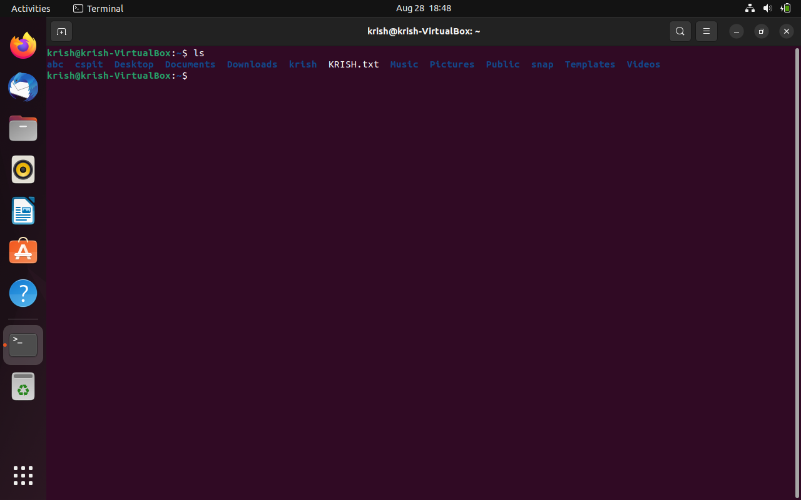

**13)** **Delete Files rm <filename>**

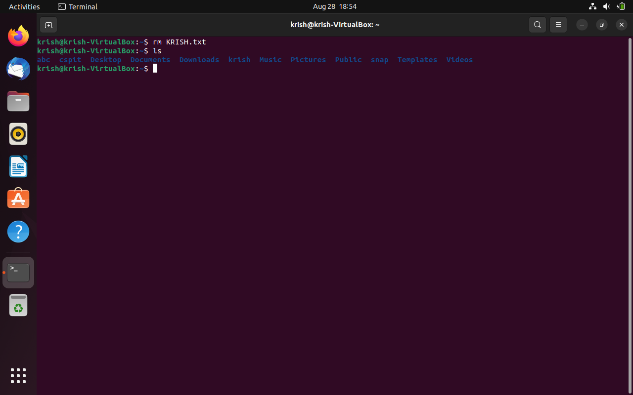

**14) Delete Directories - rm -rf <directoryname>**